Webportal.thpa.gr

url: https://webportal.thpa.gr
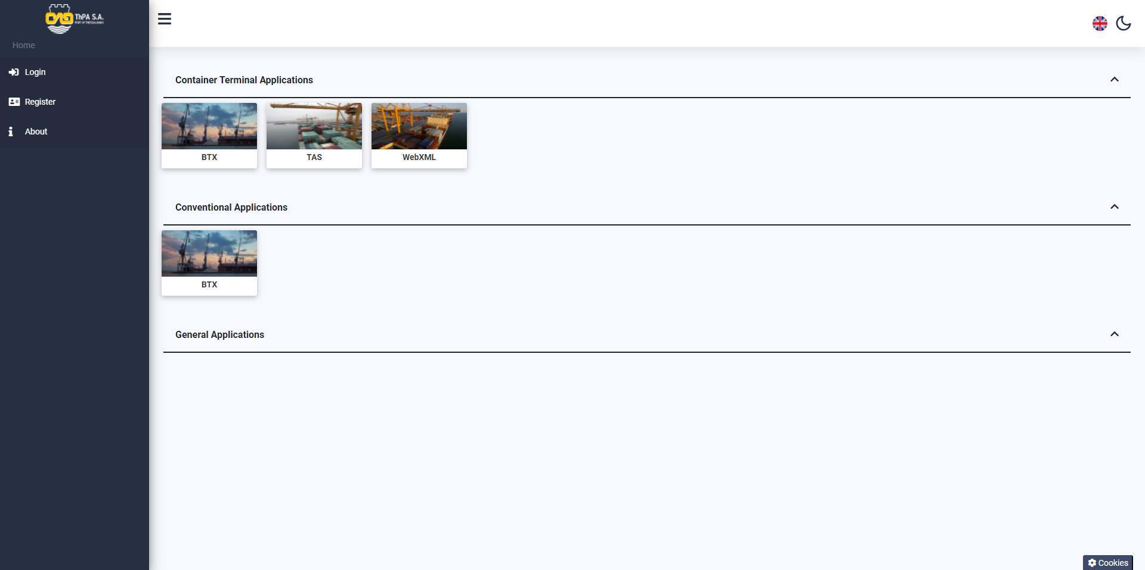

Description

Webportal brings together all available ThPA SA web applications, for easy access and management by the user. It is possible to connect the accounts you already use such as TAS, BTX with your webportal account, so you can use only one email and password to connect to the applications.

Registration
You choose Register from the side menu
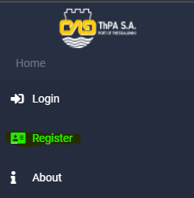
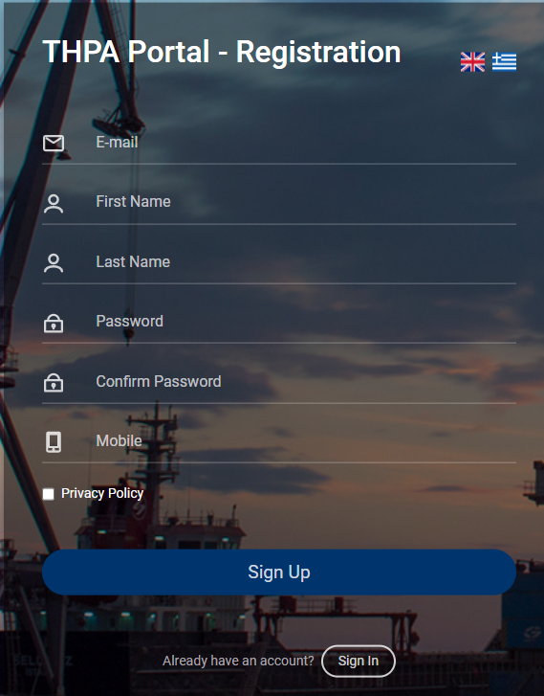
Fill in the form:
- Email
- Firstname
- Lastname
- Password
- Confirm Password
- Mobile
- Privacy Policy

Select Sign Up - You will be sent an email with a confirmation code. Enter the Verification Code you received in the email and select OK.
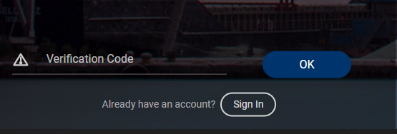

Login two way authentication
Select login from the side menu. Fill in the email and password
you registered and press Sign In.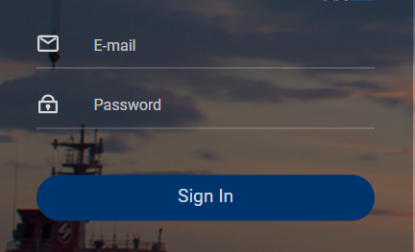
An email with authentication code will be sent to your email, which you enter and click Login.
Select “ I’m on a trusted device “ if you do not want to repeat the 2FA (two factor authentication) process for your device.

.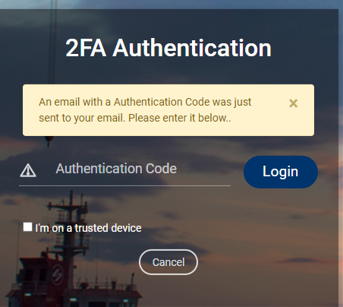

Dashboard
After a successful connection you are taken to the main screen.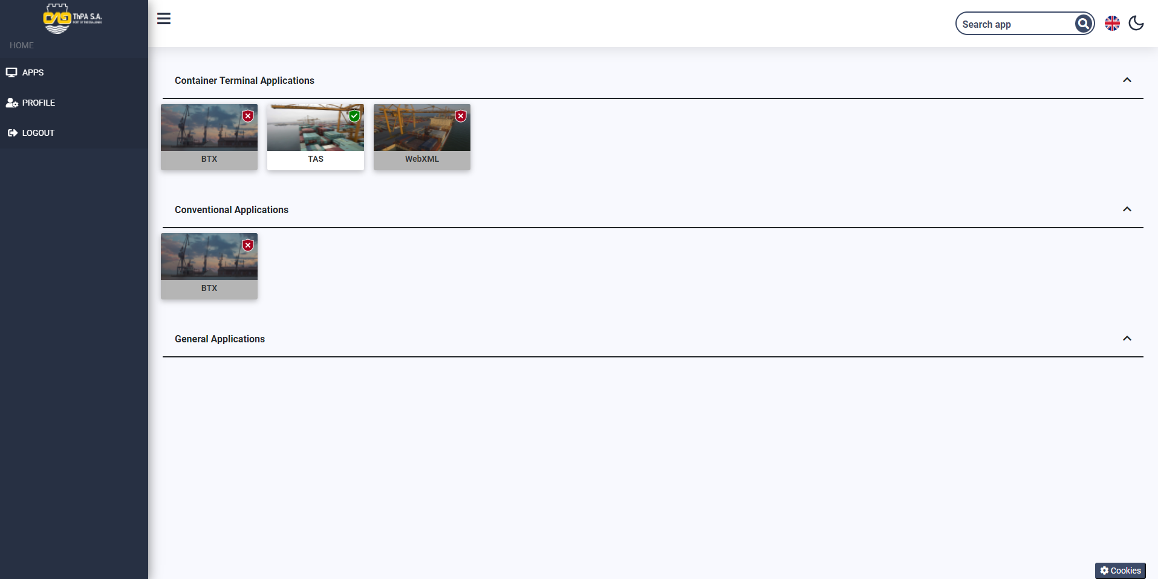
In the upper right of the screen you can search by application name.
You can also switch to Dark mode by selecting the moon icon.
Available applications are displayed as cards. The applications that have the green (tick) on the top right, means that the connected account has access to the application, while the applications with the red (X) do not.
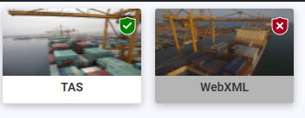
By selecting an application that you have access to, you are either taken to the application login page, where you enter the account details (email, password) that you have in the webportal, or you are automatically connected to the application.
Selecting an application that you do not have access to will take you to a screen where you will need to enter additional information to activate the application.Profile
In the Basic Info tab you can change your basic personal information and your account password.
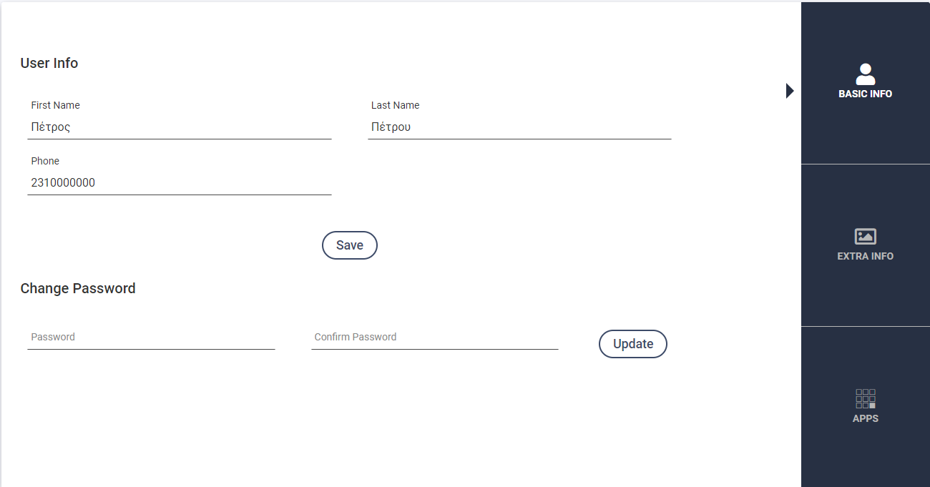

In the APPS tab you connect the old active accounts that you have in applications such as TAS, BTX, (Web access to OPS SEMPO) etc. with your webportal account.
CAUTION!!! Only one webportal account can connect to any account you already have in older applications
For the connection, select the application and enter the email, the company VAT and the password you have in the specific application and click Save.
If you have entered the above information correctly you will have access to the application with your webportal login details.
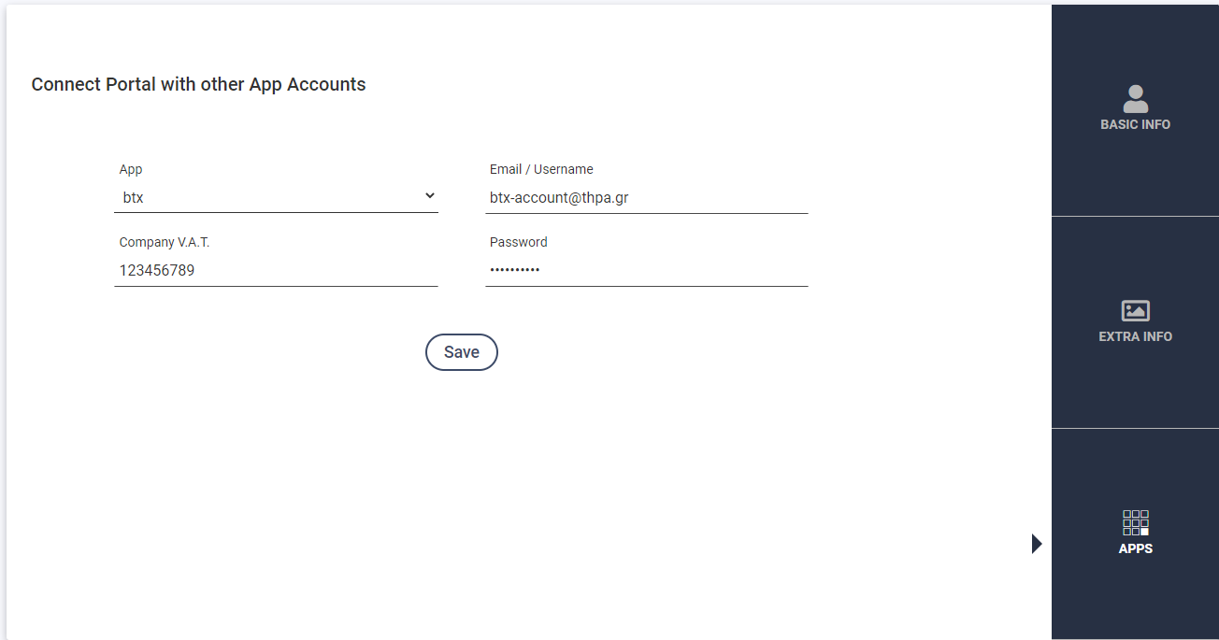

Information

The connection of the old applications with the webportal will be done gradually.
Applications that connect with Webportal are:
• ctosxml.thpa.gr (Will replace https://fnet.thpa.gr:8443/translgnet/login.jsp (Web access to OPS SEMPO)
Register on the webportal and the connection is made from https://ctosxml.thpa.gr/views/accountsync.php
TAS will be activated soon, followed by BTX.

