TAS NEW PAGE

URL: https:// tas2.thpa.gr/

1. Registration for users that have an active Account On TAS
Users that have already an active account on TAS need to register to the new portal and connect the new account with their tas account.
Registration link :https://webportal.thpa.gr/registration
After the registration login to https://webportal.thpa.gr/login and go to
https://webportal.thpa.gr/user-profile#connectApps choose TAS and input your OLD TAS username, password and company VAT.
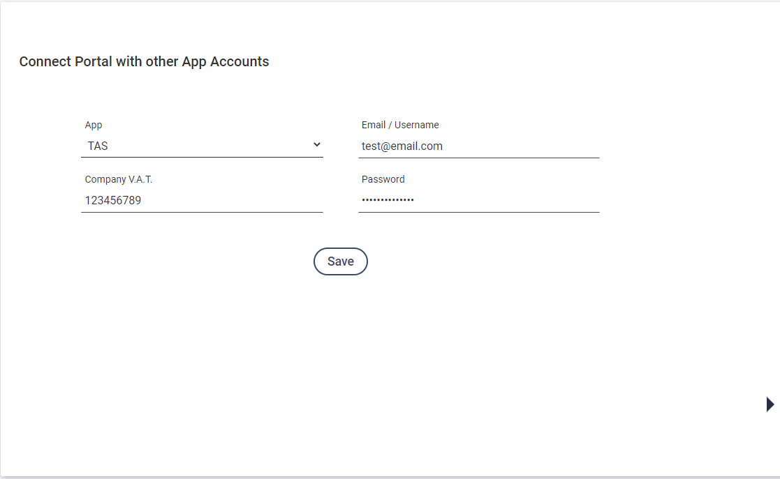
A success message will show.
Login with your webportal account credentials from https://tas2.thpa.gr/login or click on TAS.

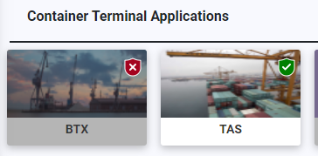
2. Registration for new Users
New users must have account on https://webportal.thpa.gr
Login https://webportal.thpa.gr and from dashboard click on TAS icon.
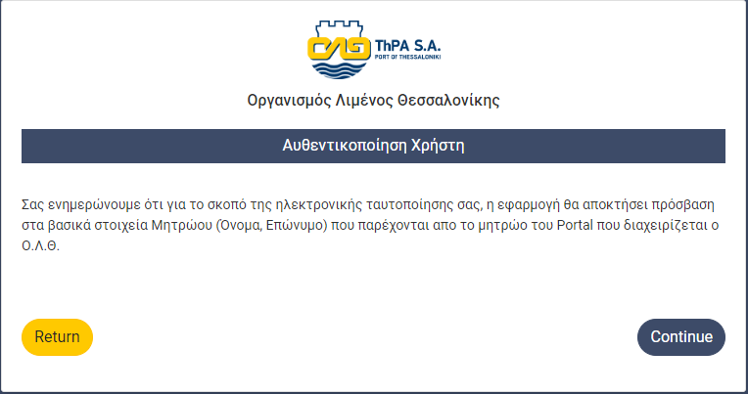Click on Button Continue. And fill the registration form and press register: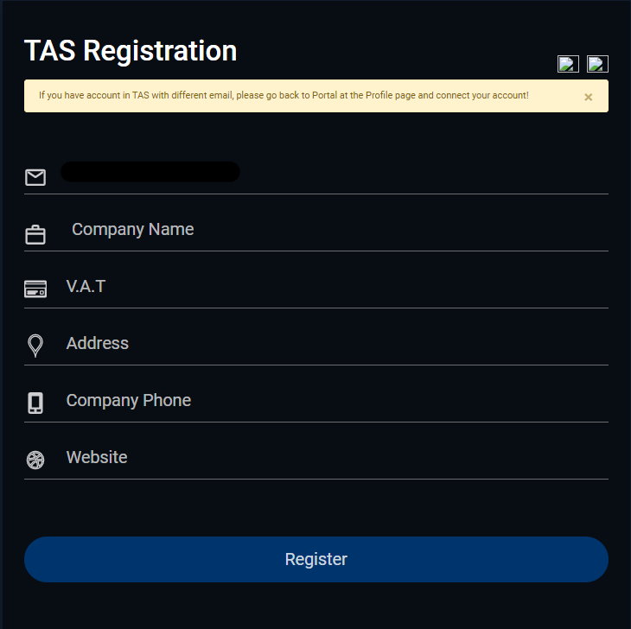
Access on TAS will be activate from TAS administrator.
3. Dashboard

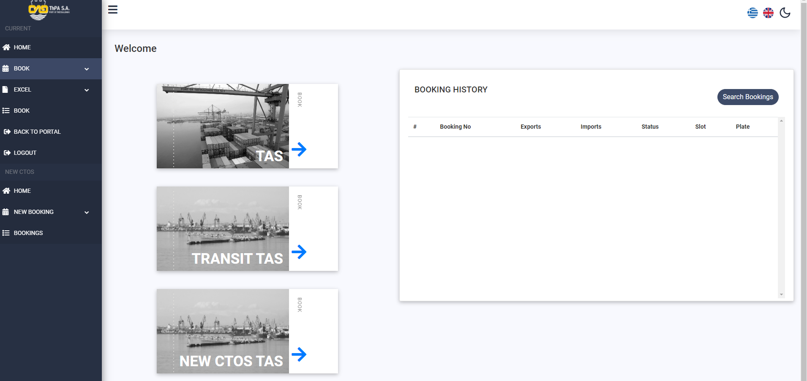

Side menu current running TOS:
- Book dropdown Normal: Choose to make appointment for non transit containers.
- Book dropdown Transit: Choose to make appointment for transit containers.
- Excel dropdown Normal: Choose to make appointments for non transit with uploading an excel.
- EXCEL dropdown Normal: Choose to make appointments for transit with uploading an excel.
- BOOKINGS: Choose to see your booking history, cancel or update a booking.
Side menu new CTOS:
- BOOK dropdown TAS: Choose to make an appointment for new TOS.
!!!Important. The is no separation from transit and non transit booking.
- BOOK dropdown Pregate: Choose to make a pre appointment for new TOS.
!!!Important. Need to be created before you enter Gate 16.

Main Page:
- TAS : Choose to make appointment for non transit containers.
- TRANSIT TAS: Choose to make appointment for transit containers
- NEW CTOS TAS: Choose to make an appointment for new TOS.
- BOOKING HISTORY: Display running appointments.

4. Create Appointment for current TOS

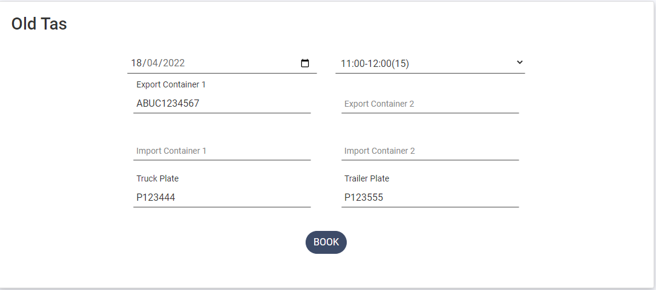
Inputs:
- Date: Booking date.
- Slot: Booking Slot Time.
- Export Container 1: Container for Deposition
- Export Container 2: Second container for Deposition.
- Import Container 1: Container to receive.
- Import Container 2: Second container to receive.
- Truck Plate: Truck plate is optional
- Trailer Plate: Trailer plate is optional
On Success a ticket will be created and will be sent to your email
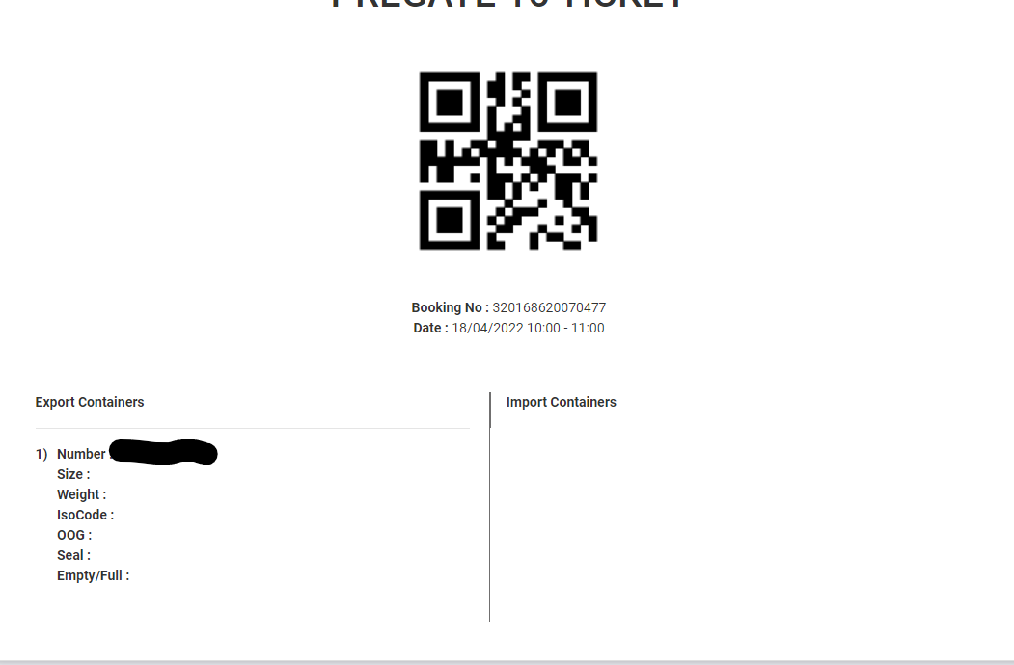
5. Create Appointment for new TOS

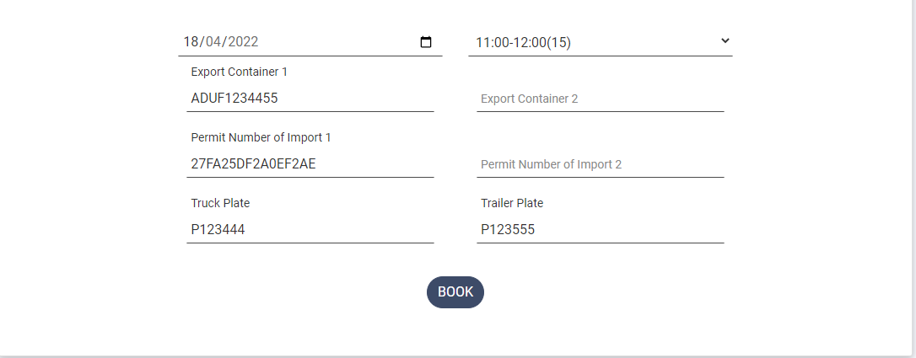

Inputs:
- Date: Booking date.
- Slot: Booking Slot Time.
- Export Container 1: Container for Deposition
- Export Container 2: Second container for Deposition.
- Permit Number Import 1: 16 digit number code of container to receive.
- Permit Number Import 1: Second 16 digit number code of container to receive.
- Truck Plate: Truck plate is required
- Trailer Plate: Trailer plate is requred
On Success a ticket will be created and will be send to your email
Procedure to Enter to Container Terminal
- Scan the QRcode on Gate 16. You will receive the Entry ticket from Gate 16.
- Scan the entry ticket QRcode on Container Terminal Gates.
IMPORTANT!!! Change to Booking cannot be done for you after the Truck pass GATE 16.
If there is a problem with your ticket you will be noted to move on resolution area.

6. Create Appointments with upload an Excel

Excel Format
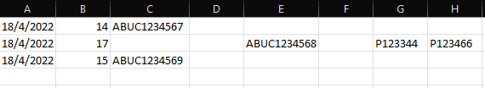
Column A: Date of book
Column B: Time of booking, (Range 8-21)
Column C: Export Container 1 Number
Column D: Export Container 2 Number
Column E: Import Container 1 Number
Column F: Import Container 2 Number
Column G: Truck Plate
Column H Trailer Plate
Upload File
Click on browse, Select your file and press Upload
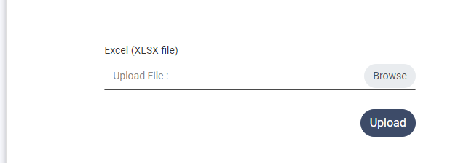

If there is no error, click save to create the appointments.
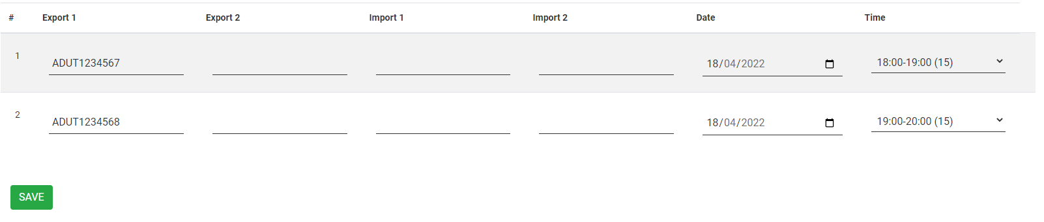
The error will be display below every row.
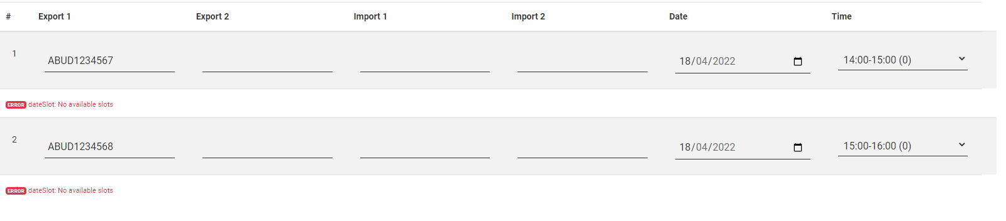
Correct the error and click save again. On success a Saved tag on the right will be displayed.
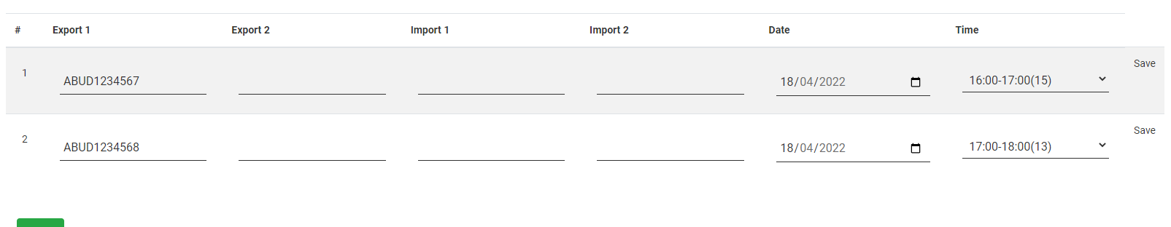

7. Booking List

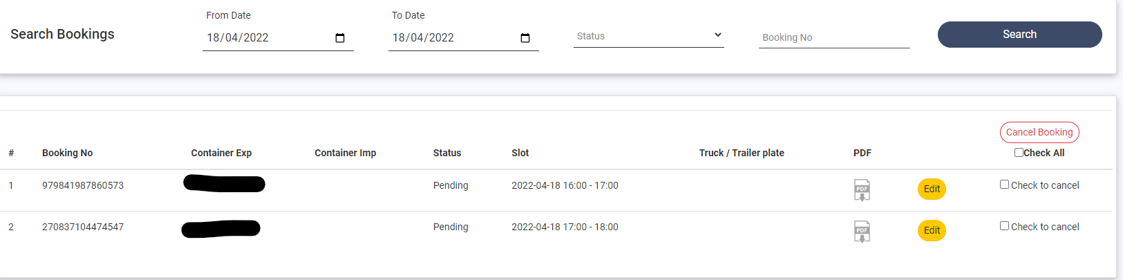

To cancel a booking check the checkbox and click Cancel booking. You can choose multiple appointments or all by click on check all.
On success a message with the booking number of appointment that cancelled will be displayed
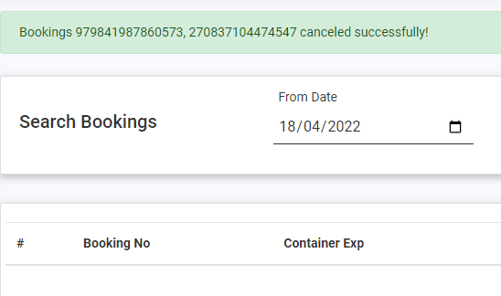

Edit Booking
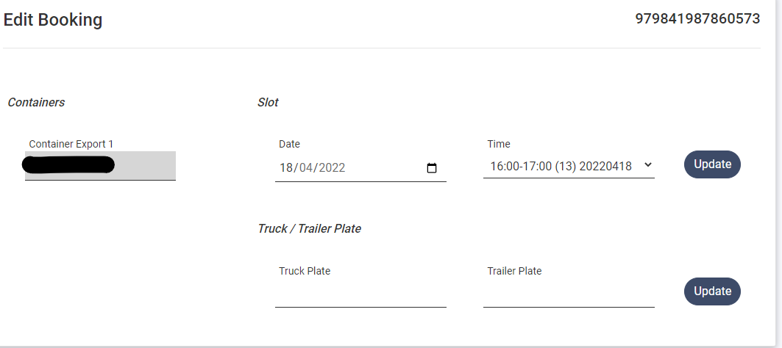
You can change the date or/and the time of an appointment.
Choose new date and time and press Update.

