CTOSXML Manual



Login-Register Application
URL:
URL: https://ctosxml.thpa.gr

Purpose:
This is a login form, in order to enter to the ctosxml applications.

How it works:
1) In order to be able to log in, you first must sign up to Portal. To sign up, you press the Sign-Up link, which is blue colored at the end of the form.
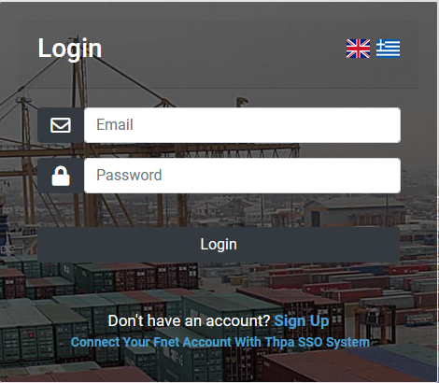

2) When you press the link, you are redirected to another form which has two registration buttons.

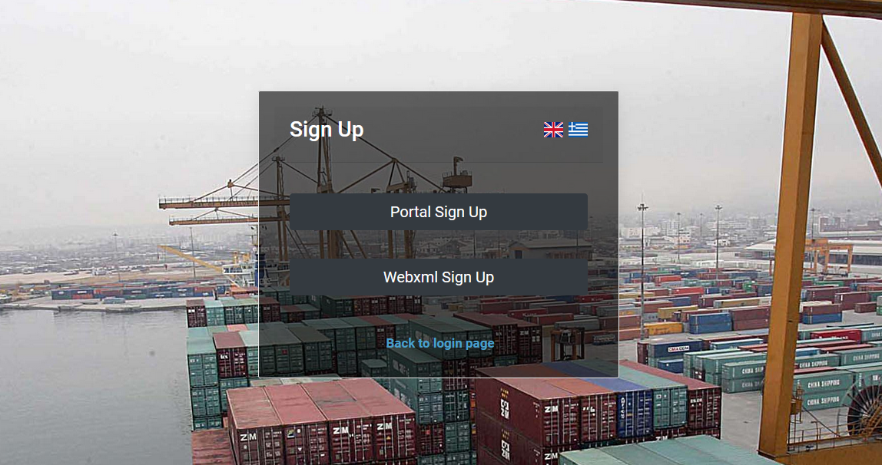

Portal Sign Up

*Note if you already have done this step for the webxml.thpa.gr or any other thpa application , you should skip this step and use the portal account that you have created before.
1) When you press the “Portal Sign Up” link, you are redirected to the Portal registration form.
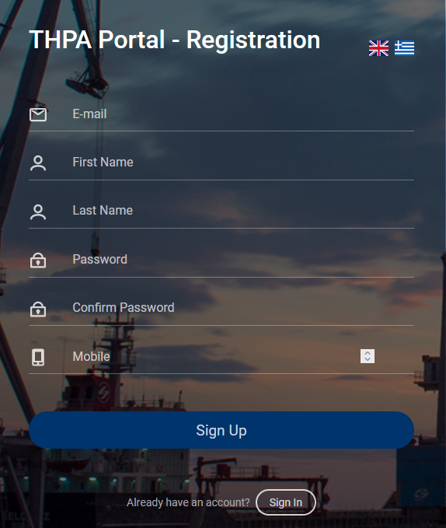

There, you must fill all the fields with the right information and press the Sign-Up button. If something goes wrong, you will receive an alert message, and the register will fail.
When the registration is successful, you receive a success message.
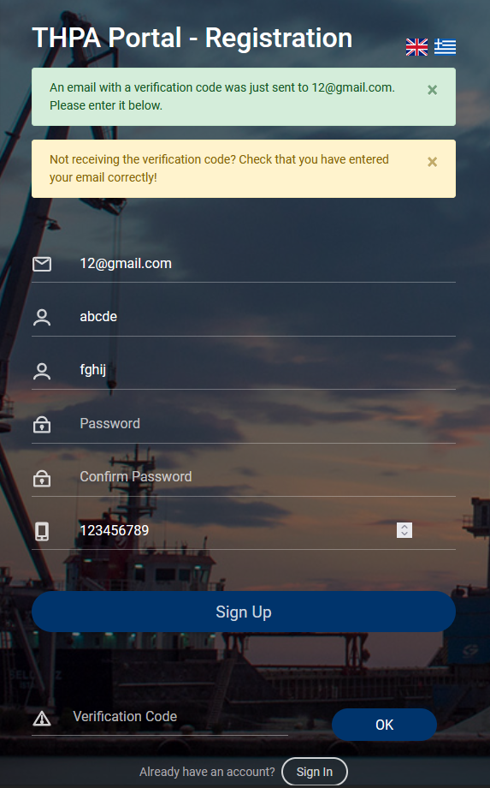
The success message informs you that you received an email with a verification code. You must enter this code to the “Verification Code” field and then press the “ok” button.
If you enter the right verification code, then you will be redirected to the Portal Sign In form.
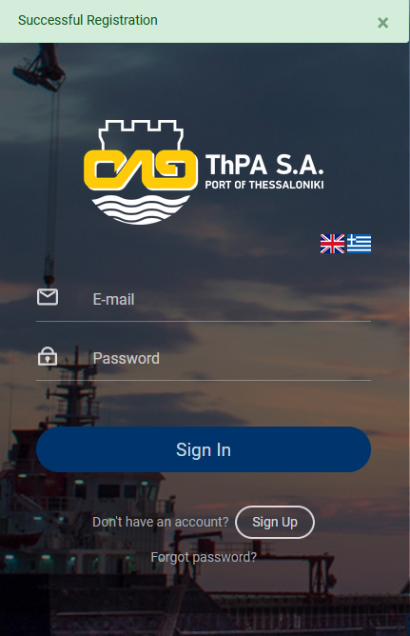

Ctosxml Sign Up

1) When you press the “Ctosxml Sign Up” link, you are redirected to the Ctosxml registration form. If you don’t have a Fnet Account, you must sign up to Ctosxml.

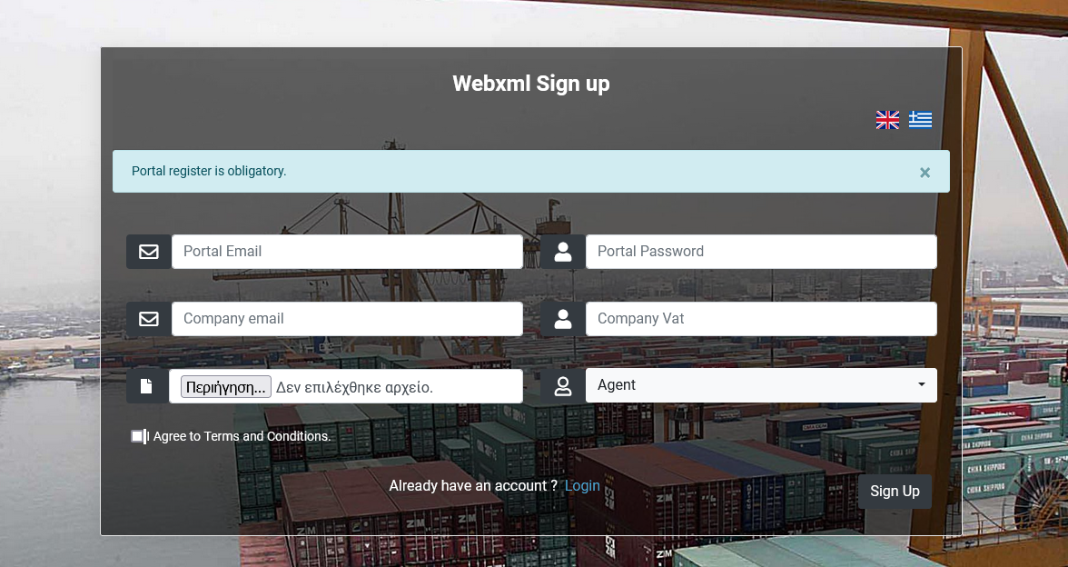
There, you must fill all the fields with the right information, agree with terms and conditions and press the Sign-Up button. If something goes wrong, you will receive an alert message, and the register will fail.
To Sign Up to Ctosxml, first you have to successfully register to Portal.

When the registration is successful, you receive a success message, and you have to wait till your request is approved. When your request is approved you will receive an email.

Fnet Connection

1) If you already have an Fnet account,you don’t have to do Ctosxml registration. To connect your Fnet Account with Thpa SSO System, you have to redirect again to login form, by https://ctosxml.thpa.gr.

There, you must press the blue colored link “Connect Your Fnet Account With Thpa SSO System” which is at the bottom of the form.

2) You are redirected to the Connection form.

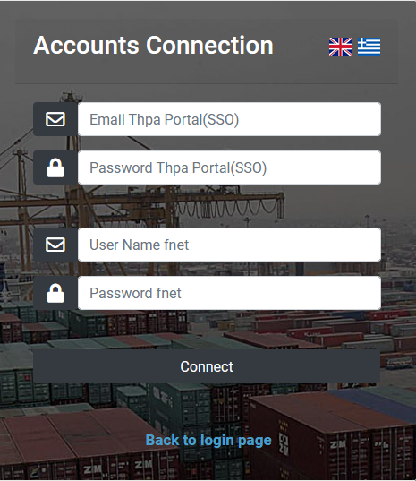

You must enter the Portal credentials and the fnet ones you used at the old system. After that, you must press the “Connect” Button. If you do it successfully, you receive a success message, that informs you that the accounts are connected.

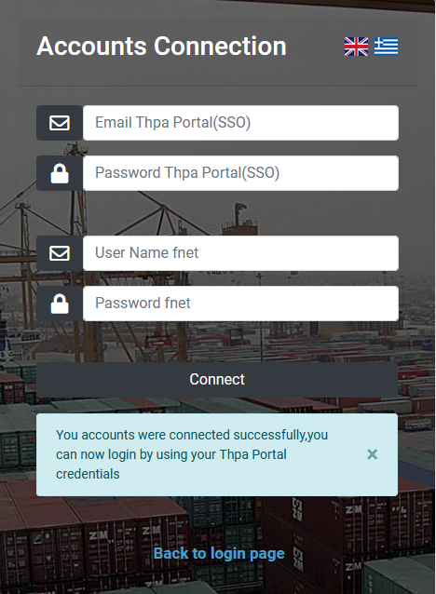

Otherwise, you will receive an alert message which informs you that the credentials are invalid.

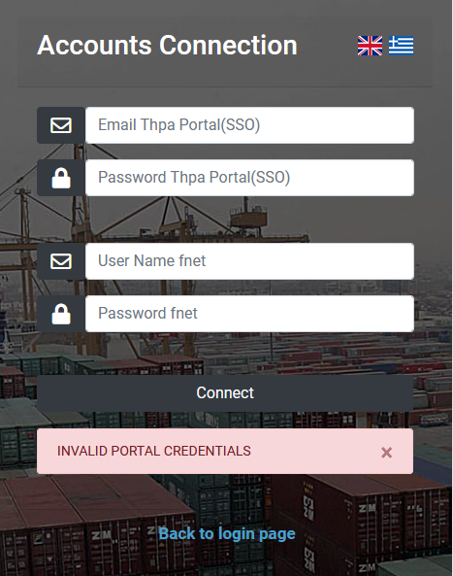
3) When the accounts are successfully connected, you press the blue link at the bottom of the page to go back to login page.

4) In order to log in successfully, you must enter the email and the password you used to portal register and press the login button. If the elements you entered are wrong, you will receive an alert message and the login will fail.

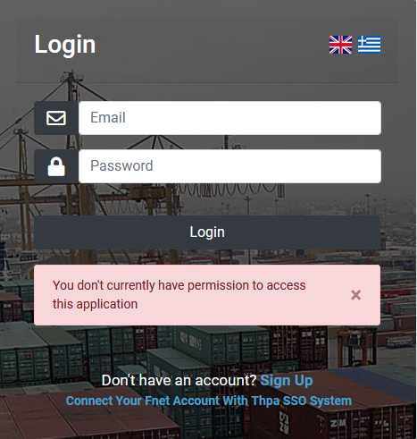

If the login is successful, you are redirected to “ctosxml send messages” form.

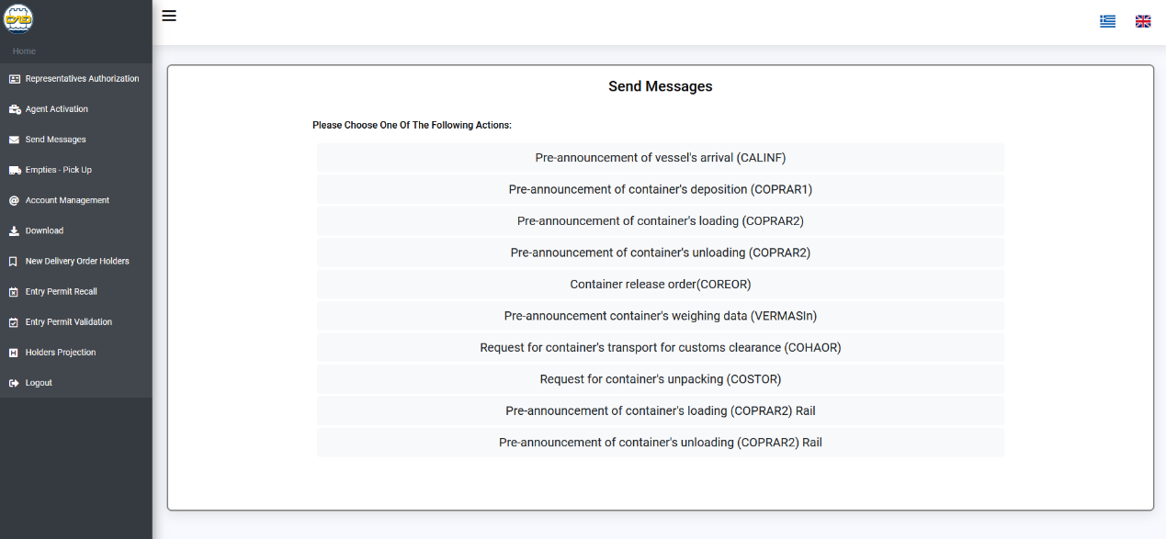

If you want to log out, you press the sidebar “Logout” button and you are redirected to login form.

Send Messages Application

URL:
https://ctosxml.thpa.gr/ctosxmlmessages/views/sendmessages.php

Purpose:
This application creates and returns the XML file of the container pre-announcement or request action you choose.

How it works:
1) You log in by submitting the “Login” form.

2) When you are successfully logged in you are redirected to the “Send Messages” Page. This page has a list with all the possible actions to choose.

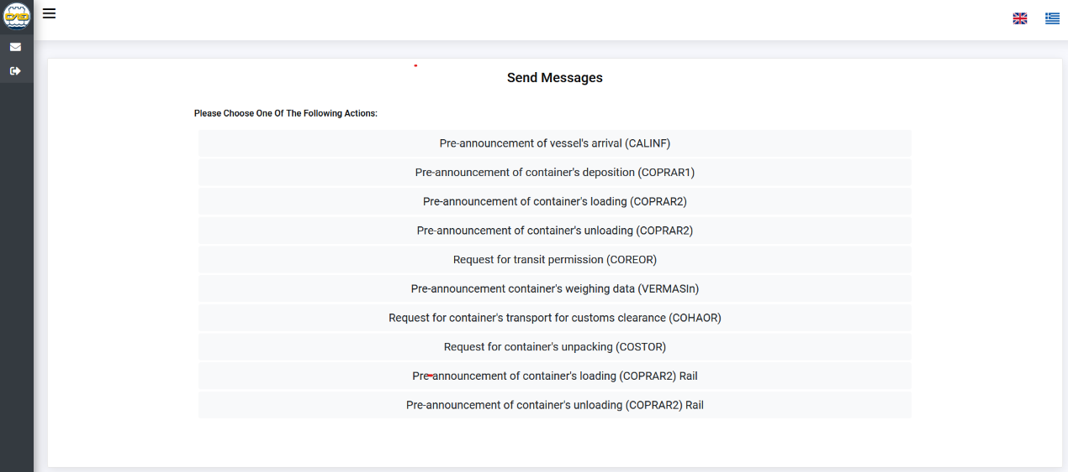

3) You choose the action you want by clicking its button and you are registered to the relevant form. In the example we choose the “Request for container’s unpacking (COSTOR) action.

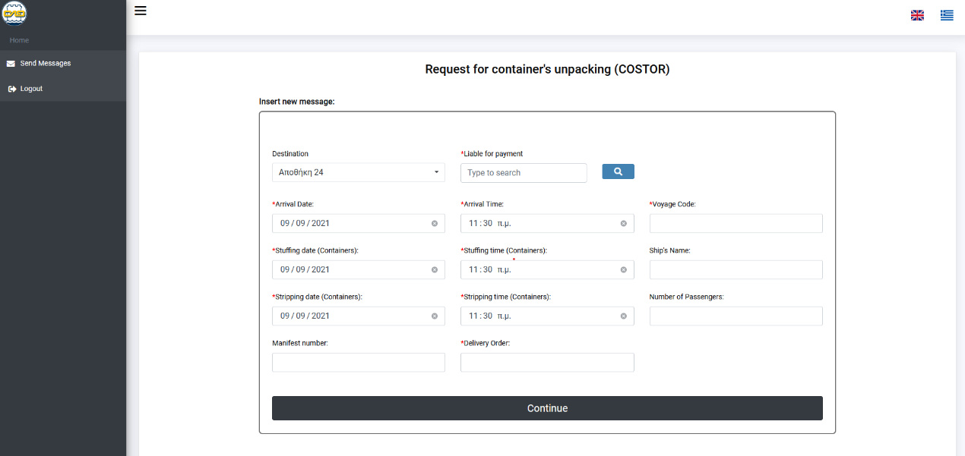

Every field that has a red star (*) next to it, is necessary to be filled. The others are optional. If you don’t fill the red star fields, you will receive an alert.

Every field that has a blue search button next to it has a searching capacity. At first you enter the whole word (or the first letters of it) of what you want the input to be and then you press the search button. After that, you enter again the word (or the first letters) and a navigation bar appears, from which you choose the one you want.

4) You press the “Continue” button and you are registered to another page, where there is a success message and a button to download the XML File. Downloading the XML File is not necessary and is only for personal use.

Empty Container Application

URL:
https://ctosxml.thpa.gr/views/empties.php

Purpose:
This application creates and returns the QR Codes PDF of the empty containers you want to pick up.

How it works:
1) You send the elements of the containers you want to collect in the body of the HTTP POST request.
You press the “Add Container” button as many times as the different types(based on ISO) of containers you want to collect and there will be created the exact same number of rows with fields.(Only containers with the same type,size,height are allowed in the same booking)
In “Quantity” box you enter how many same containers you want to collect.
In “Box Operator” box you choose from the list of your box operators(list is generated based on the available import empty containers in the yard).
In “ISO Code” box you select the code of the containers. When you enter the ISO Code, the Type, Size, Height boxes will be field by default.
In “Number” box you enter the Container Number of a specific container you want to collect. When you enter the Container Number, you don’t need to enter the ISO Code.
If you want to delete a row you press the “Delete” button.
When the form is filled, you press the “Submit” button.
There is also the option to print two 20’ containers per ticket, with the same QR code, by checking the box at the right.
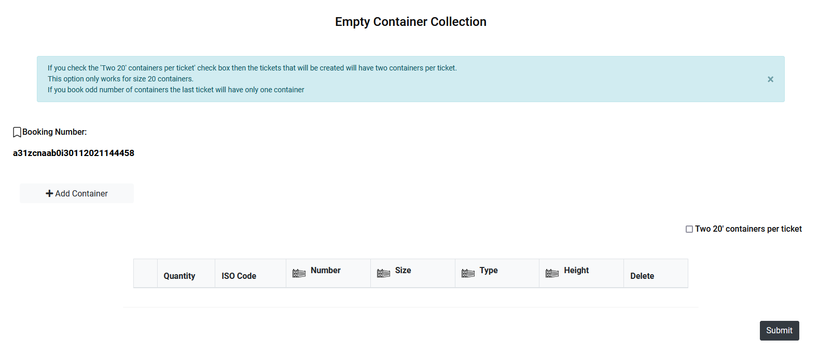
2) You redirect to another page, where there is a success message and a button to download the QR Code PDF.
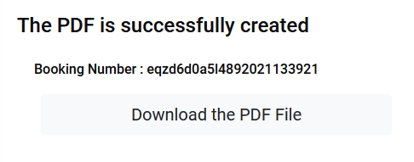

3) When the “download” button is pressed, the QR Code PDF starts to download in your device in the form you choose.

If something goes wrong at stage 1, you will receive an error alert and the PDF will not be created. The error you receive is either Technical, or Data.

Errors
Technical Errors
If there is a technical error, you will receive a response as an alert message.

Data Errors
If there is a Data error, you will receive one of the following responses as an alert message:

• There are no inputs in the form.

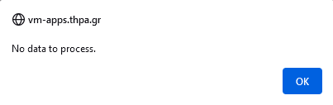

• Inputs are wrong, or a specific container (or more) are not in the yard.

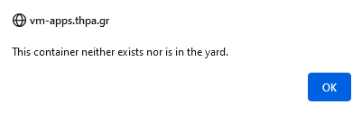

• One or more of the containers are already booked.

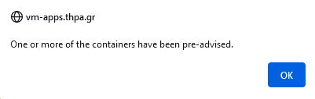

• The container is not empty.

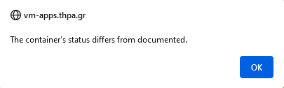

Account Management Manual

URL:
https://ctosxml.thpa.gr/views/accountManagement.php

Purpose:
This application is about the management of the e-mail addresses and the FTPs.

How it works:
The account management page has two buttons. The first one is about Email Management and the second one is about FTP Management. By pressing the one you want, you are redirected to another page.
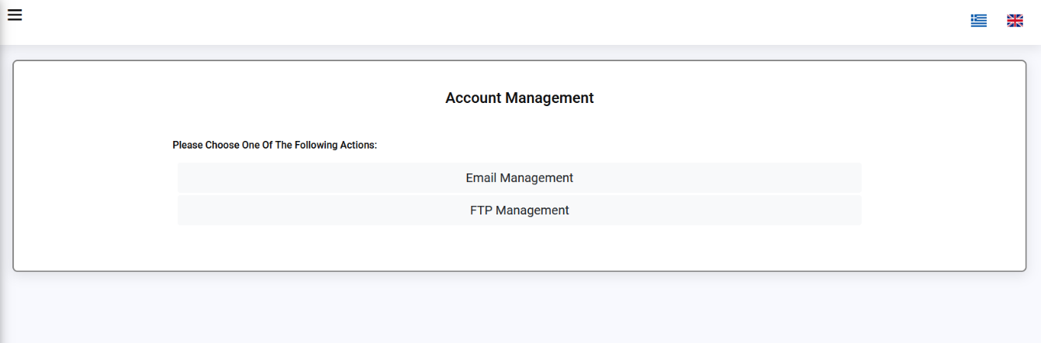

Email Management

URL:
https://ctosxml.thpa.gr/views/accountManagementEmails.php

Purpose:
This application is about the management of the e-mail addresses. You choose in which address you want to receive e-mails/XMLs.

How it works:
1) You choose the Email Management button.
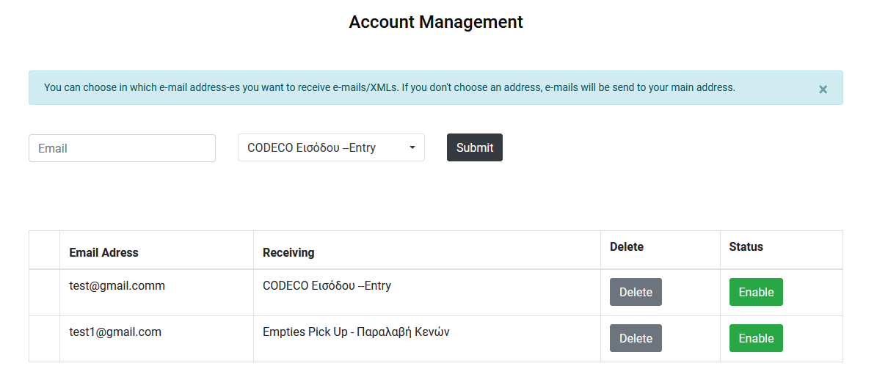
2) When you are successfully in, you are redirected to the “Account Management” Page. At the top of the page there is one filling field, one selecting field and one “Submit” button. With these you can list a new email, by filling the fields and pressing the “Submit” button. You must enter a valid e-mail that is not already listed with the same type, or you will receive an alert.
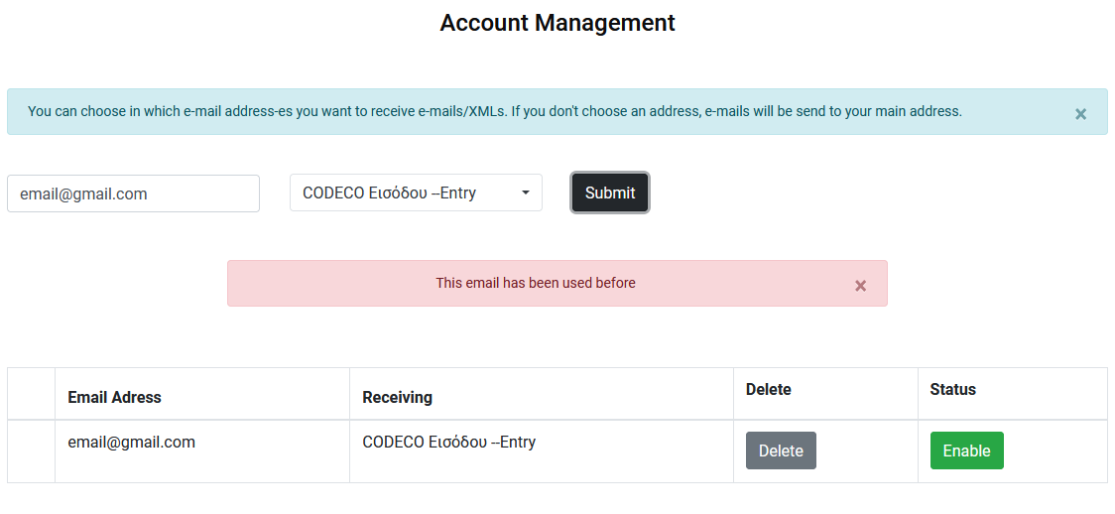

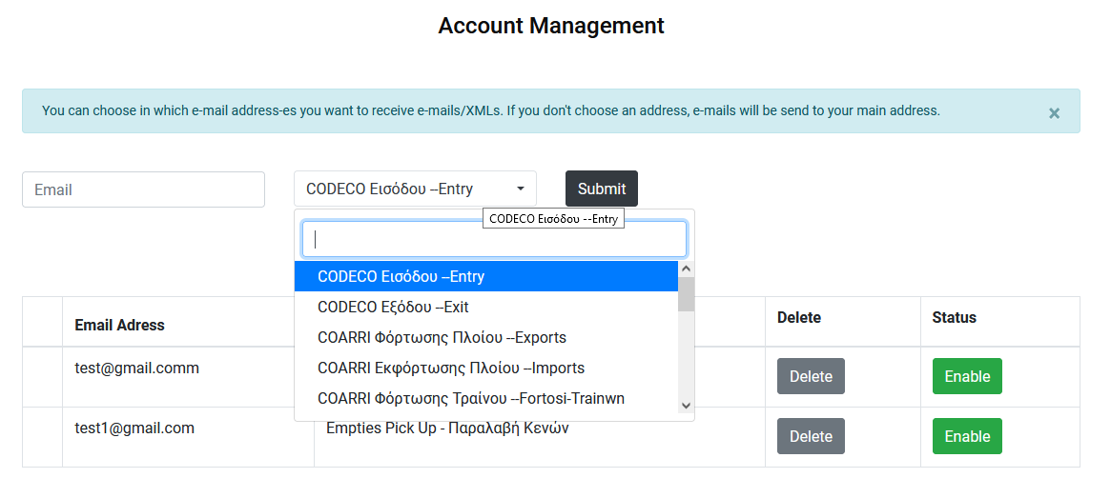
3) This page has also a list with all the e-mail addresses of the user. Each row of the table has the type, the status of the e-mail and a delete button. If you have no emails listed, there will be showing an empty table.
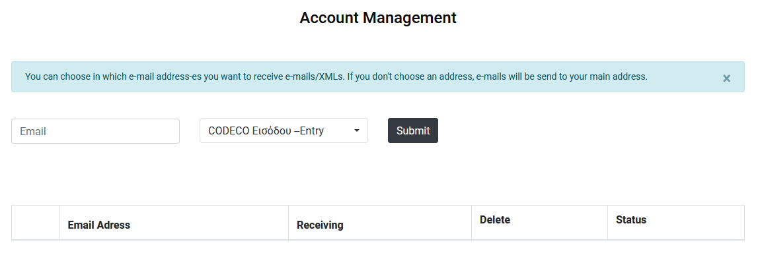
The status button is either red or green. It depends on the activeness of the e-mail. If the e-mail is active, the button is red and says “Disable”. If the e-mail is unactive, the button is green and says “Enable”. By pressing the button, you can change the activeness of the e-mail.
If you press the delete button, the specific email of the row will be deleted. If you already deleted an e-mail and you want to have it back, the only thing you can do is to list it again, by filling the fields at the top of the form and pressing the “Submit” button.

New Delivery Order Holders Manual

URL:
https://ctosxml.thpa.gr/ctosxmlmessages /views/newholders.php

Purpose:
This application is about adding the new delivery order holders.

How it works:
1) You log in by submitting the “Login” form.
2) When you successfully log in, you redirect to the “New Delivery Order Holders” page. At this page there are three fields and one submit button. The first field is about adding the VAT, the second one is about adding the Company and the third one is about the .pdf file.
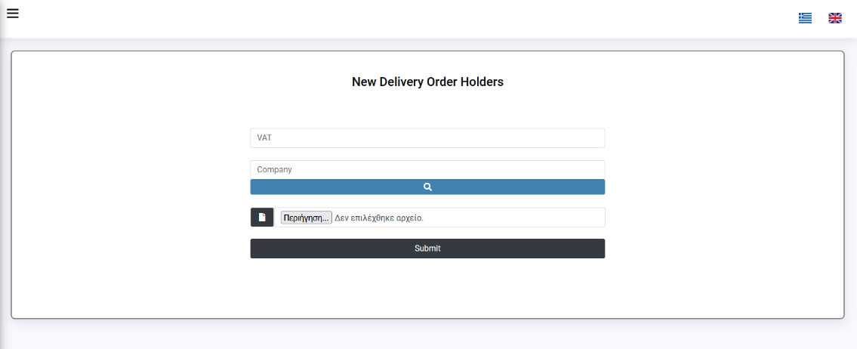

3) When the agents fill all the fields with success, they add one new holder to the system. Agents should add the right VAT and the right .pdf file, to successfully add a new holder. If there is something wrong with the data they filled, they will receive an alert message.
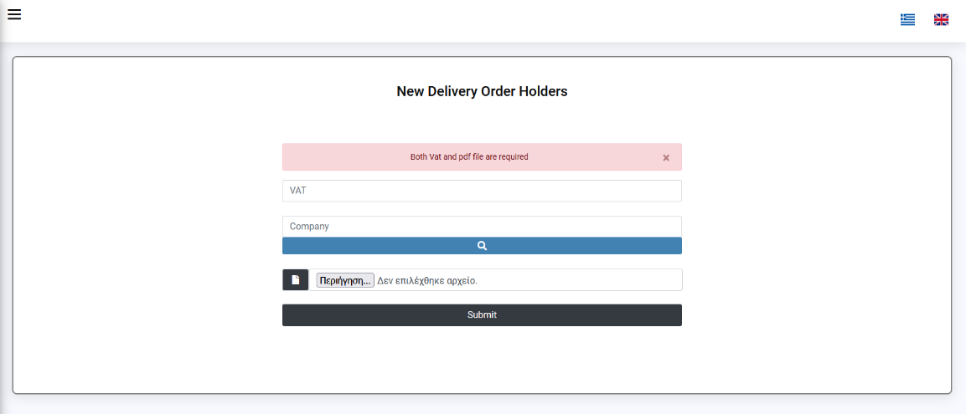

Entry Permit Validation Manual
URL:
https://ctosxml.thpa.gr/ctosxmlmessages/views/entrypermitreaprove.php

Purpose:
This application is about the validation of the Entry Permits. After the check of the Permits, there is a reform of the data and automatically emails send at the appropriate parties.

How it works:
1) You log in by submitting the “Login” form.
2) When you are successfully logged in you are redirected to the “Entry Permits Validation” Page. This page has a list with all the Entry Permits.
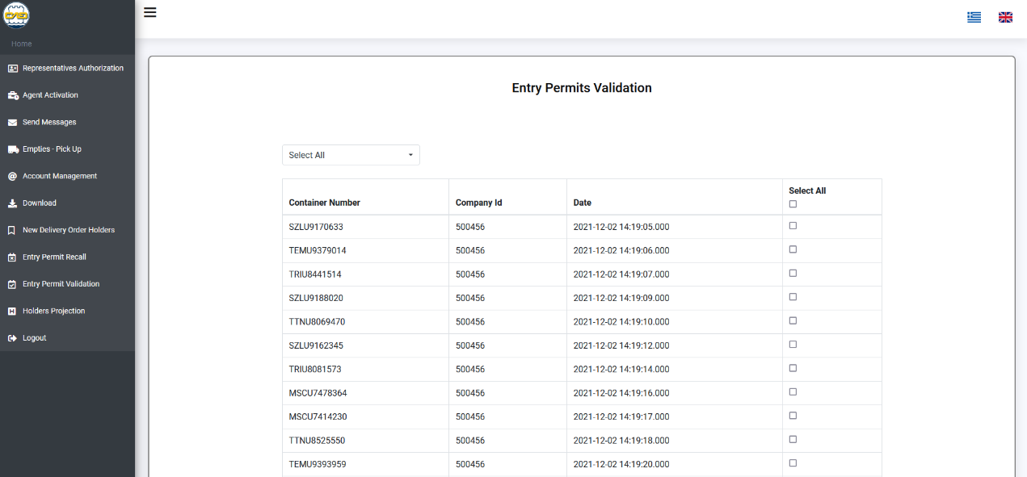

3) You can either choose to see all the Entry Permits, or you can choose to see a specific one by choosing the “By ID” button to the navbar. If you choose the “By ID” button, a Container Number field pops up.
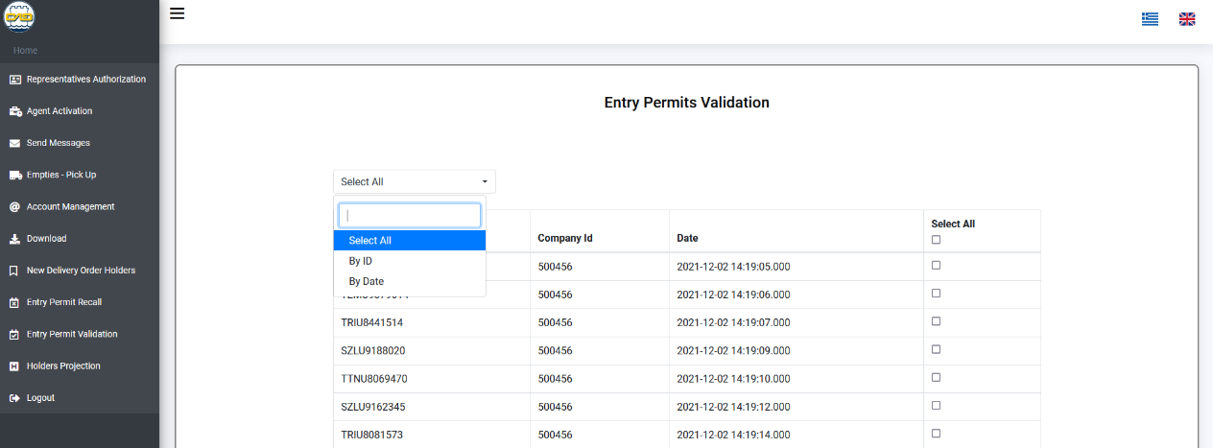

4) You choose the Entry Permit you want to delete, by clicking its “Select” button. You can choose multiple ones and you can also select them all by the “Select all” button. (In the example below, I choose to delete them all, so I press the “Select All” button.

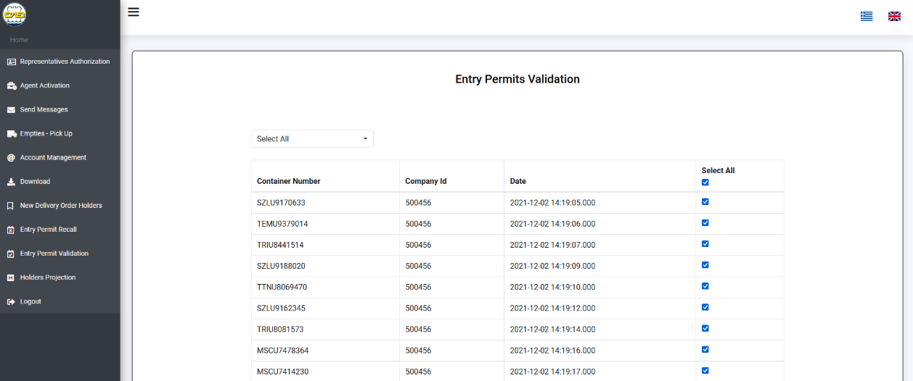

5) After the selecting, you press the “Submit” button and the page is refreshing automatically. The new list has all the elements you didn’t click before. (In the photo below, the refreshed list is empty, because I chose before to delete all the elements).

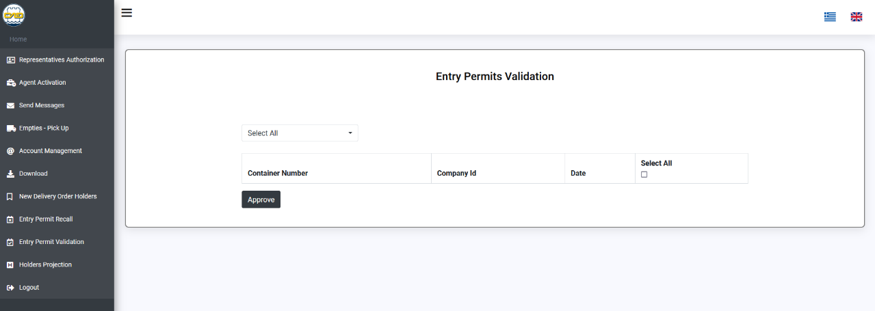If something isn’t right with the process, you receive an alert which informs you about it

Entry Permits Recall Manual

URL:
https://ctosxml.thpa.gr/ctosxmlmessages/views/entrypermitrecall.php

Purpose:
This application is about the recall of the Entry Permits. After the correction of the checked Permits, there is a reform of the data and automatically emails send at the appropriate parties.

How it works:
1) You log in by submitting the “Login” form.

2) When you are successfully logged in you are redirected to the “Entry Permit Recall” Page. This page has a list with all the not checked Entry Permits. At the left of the screen there is a “Permits Validation” button, which redirects you to the specific page. This page has a list with all the checked Entry Permits. The process is the same with the “Entry Permit Validation” one.

Holders Manual

URL:
https://ctosxml.thpa.gr/ctosxmlmessages/views/holders.php

Purpose:
This application is about the view of the holders. After the new additions of the holders, there is this view that shows all the new additions.

How it works:
1) You log in by submitting the “Login” form.

2) When you are successfully logged in you are redirected to the “Holders” Page. This page has a list with all the new holders. At the top of the screen there are a “Company Name” field and a search button, with which you can search for a specific Holder by entering its number.
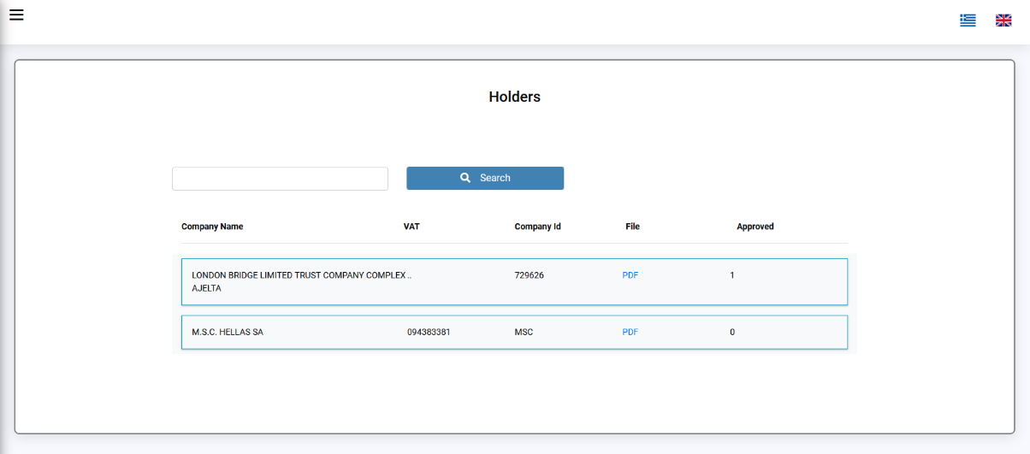

XML Response Monitor Manual

URL:
https://ctosxml.thpa.gr/ctosxmlmessages/views/xmlResponse.php

Purpose:
This application is about the view of the messages.

How it works:
1) You log in by submitting the “Login” form.

2) When you are successfully logged in you are redirected to the “XML Response Monitor” Page. This page has a list with all the messages. At the top of the screen there are “XML Code” and “Voyage” fields, a “Type” select field and a search button. By entering one or more information in those fields and pressing the search button, you can search for a specific message.

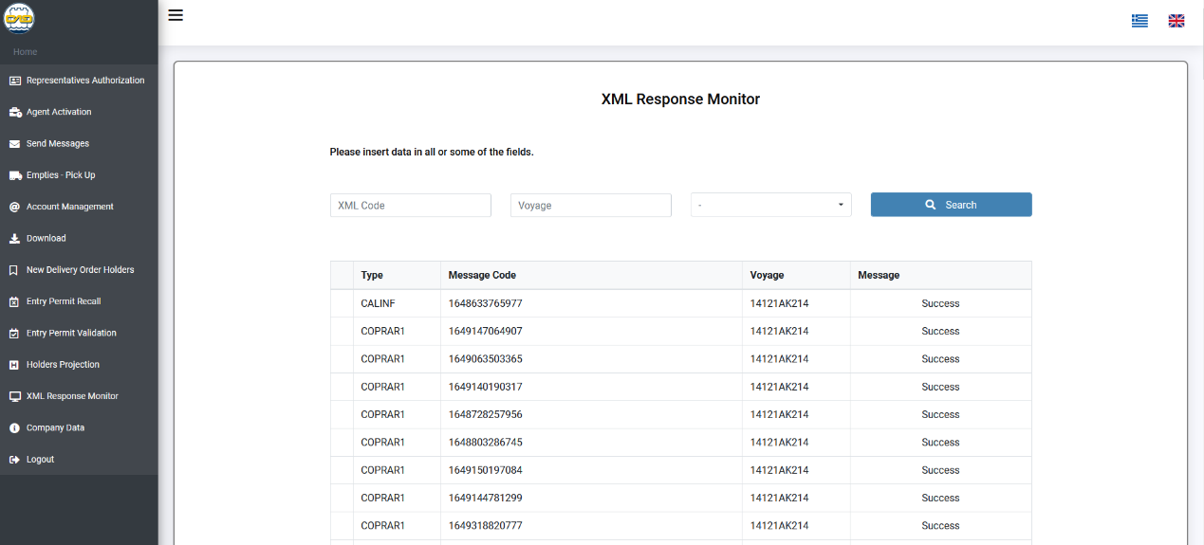

3) If there is no message which matches with the information you entered, or you press the “search button” without entering information, you will receive an alert message and the table will be empty.

4) In order to see the error message of a XML, you have to press the “Show Error Message” button.

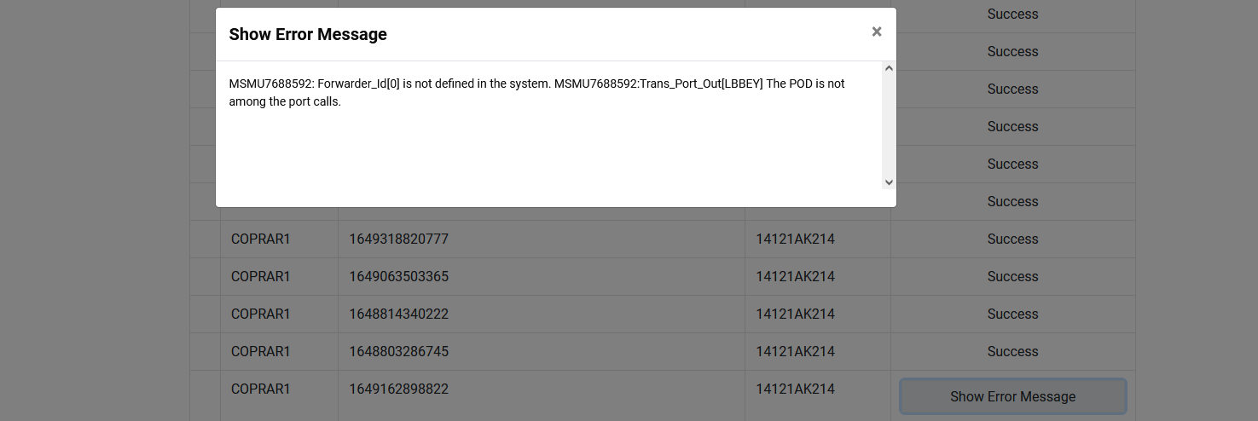

Company Data Manual

URL:
https://ctosxml.thpa.gr/ctosxmlmessages/views/companyData.php

Purpose:
This application is about the view of the company Data.

How it works:
1) You log in by submitting the “Login” form.

2) When you are successfully logged in you are redirected to the “Company Data” Page. At the top of the screen there are a “Vat” field and a search button. By entering the Vat and pressing the search button, you can search for the information. If there are no data for the Vat you entered, you will receive an error alert message.

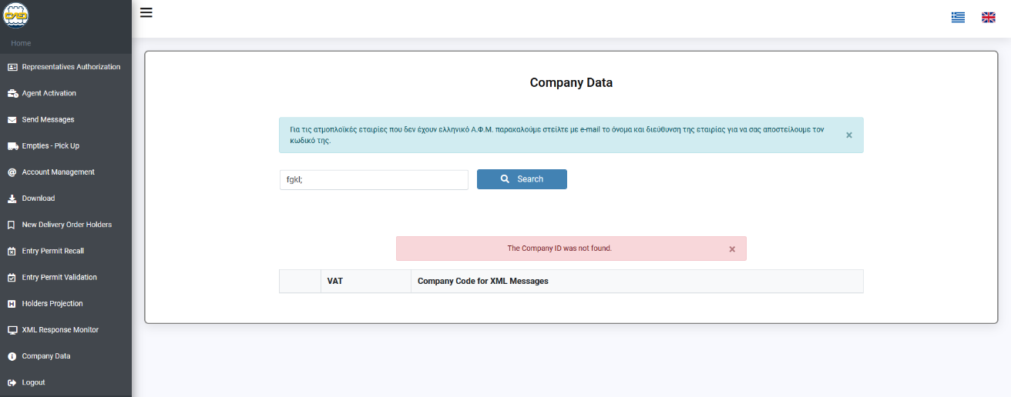

If you enter a valid “Vat” you will receive all the information about it.

