CTOSXML Manual


Login-Register Application
URL:
URL: https://ctosxml.thpa.gr

Purpose:
This is a login form, in order to enter to the ctosxml applications.

How it works:
1) In order to be able to log in, you first must sign up to Portal. To sign up, you press the Sign-Up link, which is blue colored at the end of the form.
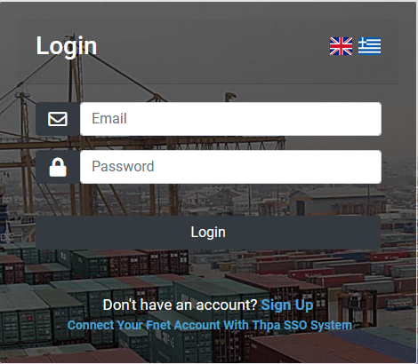

2) When you press the link, you are redirected to another form which has two registration buttons.

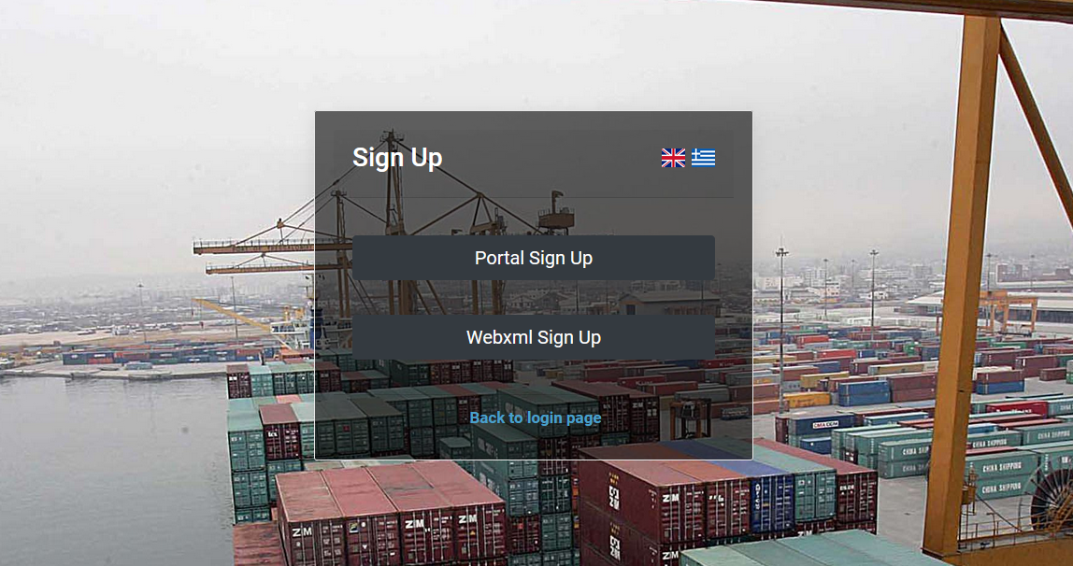

Portal Sign Up
*Note if you already have done this step for the webxml.thpa.gr or any other thpa application , you should skip this step and use the portal account that you have created before.
1) When you press the “Portal Sign Up” link, you are redirected to the Portal registration form.
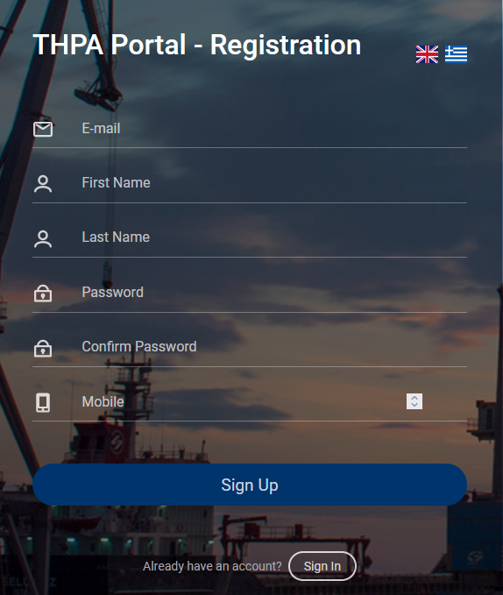
There, you must fill all the fields with the right information and press the Sign-Up button. If something goes wrong, you will receive an alert message, and the register will fail. When the registration is successful, you receive a success message.

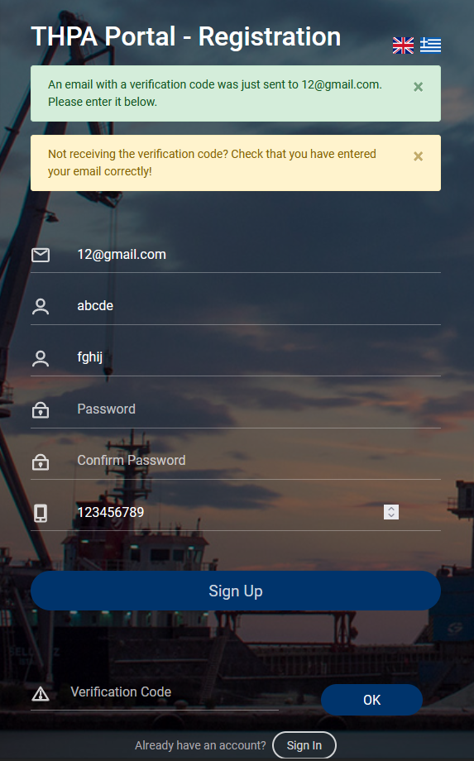

The success message informs you that you received an email with a verification code. You must enter this code in the next 5 minutes to the “Verification Code” field and then press the “ok” button.

If you enter the right verification code, then you will be redirected to the Portal Sign In form.
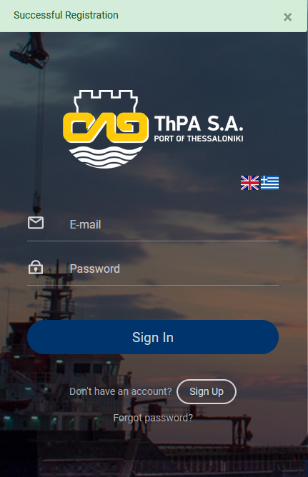

Ctosxml Sign Up

1) When you press the “Ctosxml Sign Up” link, you are redirected to the Ctosxml registration form. If you don’t have a Fnet Account, you must sign up to Ctosxml.

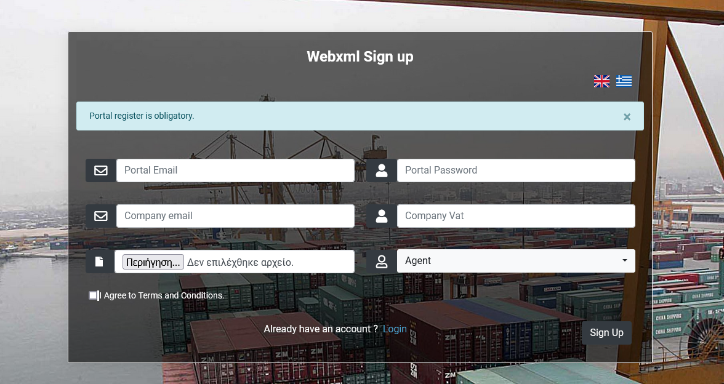

There, you must fill all the fields with the right information, agree with terms and conditions and press the Sign-Up button. If something goes wrong, you will receive an alert message, and the register will fail.
To Sign Up to Ctosxml, first you have to successfully register to Portal.

When the registration is successful, you receive a success message, and you have to wait till your request is approved. When your request is approved you will receive an email.

Fnet Connection

1) If you already have an Fnet account,you don’t have to do Ctosxml registration. To connect your Fnet Account with Thpa SSO System, you have to redirect again to login form, by https://Ctosxml.thpa.gr.

There, you must press the blue colored link “Connect Your Fnet Account With Thpa SSO System” which is at the bottom of the form.

2) You are redirected to the Connection form.

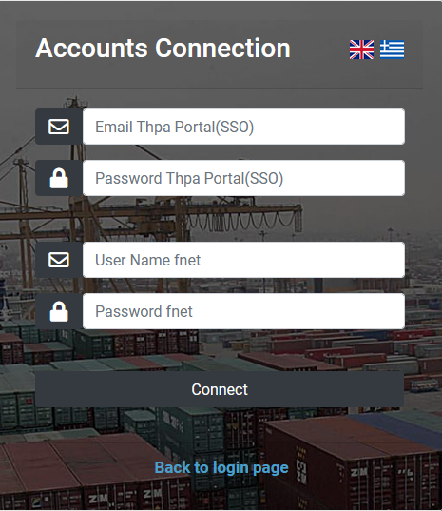

You must enter the Portal credentials and the fnet ones you used at the old system. After that, you must press the “Connect” Button. If you do it successfully, you receive a success message, that informs you that the accounts are connected.

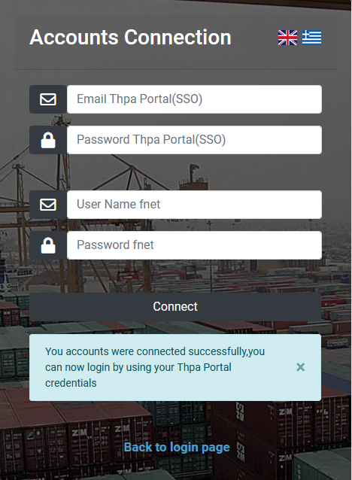

Otherwise, you will receive an alert message which informs you that the credentials are invalid.

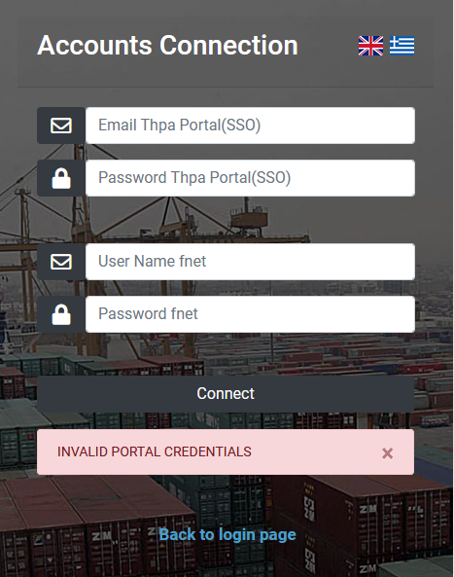
3) When the accounts are successfully connected, you press the blue link at the bottom of the page to go back to login page.

4) In order to log in successfully, you must enter the email and the password you used to portal register and press the login button. If the elements you entered are wrong, you will receive an alert message and the login will fail.

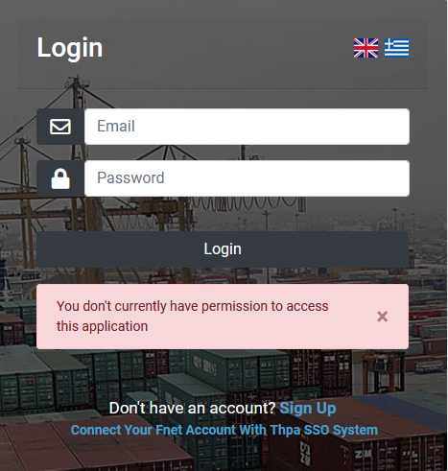

If the login is successful, you are redirected to “Ctosxml send messages” form.

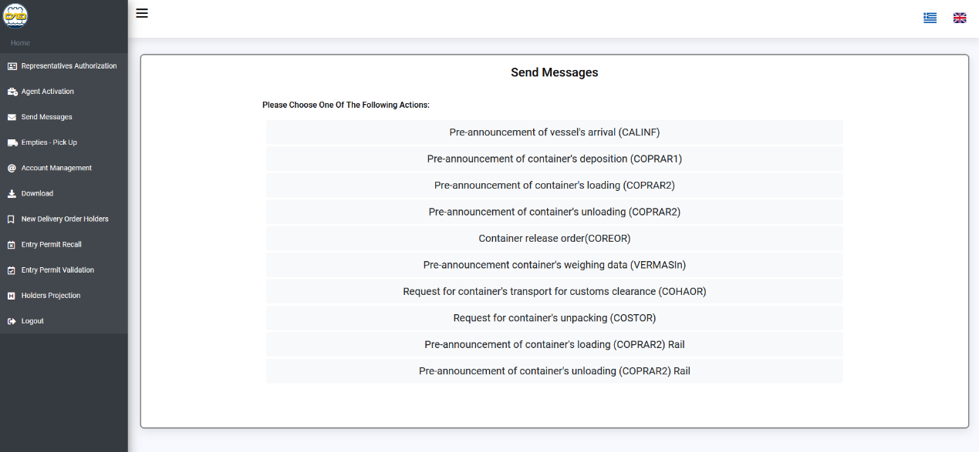

If you want to log out, you press the sidebar “Logout” button and you are redirected to login form.

New Delivery Order Holders Manual

URL:
https://ctosxml.thpa.gr/views/newholders.php

Purpose:
This application is about adding the new delivery order holders.

How it works:
1) You log in by submitting the “Login” form.
2) When you successfully log in, you redirect to the “New Delivery Order Holders” page. At this page there are three fields and one submit button. The first field is about adding the VAT, the second one is about adding the Company and the third one is about the .pdf file.
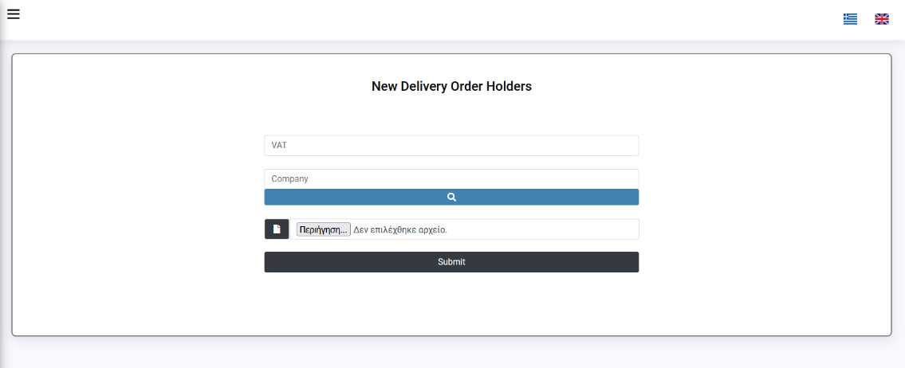

3) When the agents fill all the fields with success, they add one new holder to the system. Agents should add the right VAT and the right .pdf file, to successfully add a new holder. If there is something wrong with the data they filled, they will receive an alert message.
